<https://www.mindinventory.com/blog/angular-10-is-available-now-here-are-the-latest-features-and-updates/>

Angular 10 Features and Updates

### 1. Warnings on CommonJS Imports

A dependency packed with CommonJS in your projects can affect the speed of app loading and lead to slower functionality. However, with the Angular 10, developers have got warnings regarding using dependencies packed with CommonJS.

When you use a dependency that is packaged with CommonJS, it can result in [larger slower applications](https://web.dev/commonjs-larger-bundles/).

Starting with version 10, we now warn you when your build pulls in one of these bundles. If you’ve started seeing these warnings for your dependencies, let your dependency know that you’d prefer an ECMAScript module (ESM) bundle.

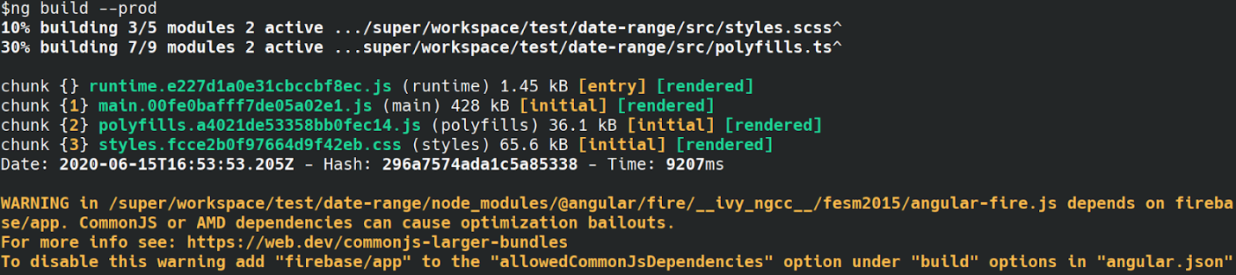

### 2. Optional Stricter Settings

Angular 10 provides a stricter project setup for making a new workspace using ng new.

ng new –strict

After allowing this flag, it starts with the new project using some new settings that enhances maintainability, allows the CLI for performing advanced optimizations on the app, and helps catch bugs properly beforehand. Permitting this flag helps app configuration as side-effect free to make sure more developed tree-shaking.

* Enables strict mode in TypeScript
* Turns template type checking to Strict
* Default bundle budgets have been reduced by ~75%
* Configures linting rules to [prevent declarations of type any](https://palantir.github.io/tslint/rules/no-any/)
* Configures your app as side-effect free to enable more advanced tree-shaking

### 3. New Date Range Picker

Angular 10 has come with the all-new date range picker. To use it, you can utilize elements of both mat date range picker and mat date range input.

To use the new date range picker, you can use the mat-date-range-input and mat-date-range-picker components.

### 4. Boost in ngcc Performance

You can see a boost in performance that is accomplished by lowering the entry point’s size. Moreover, hiding of dependencies is implemented inside the entry point exhibit and is read from there as compared to being computed every time.

### 5. Async Locking Timeout

Async locking timeout’s configuration is still probable, which may include assistance in the ngcc.config.js file, adjusting the retry delays and retry attempts in the AsyncLocker.

### 6. Removals and Corrections

The main Angular developer team has executed much deprecation and removed some things from this platform.

For example, FESM5 or ESM5 bundles have been taken out from the Angular Package Format and this lowered the file size by at least 119 MB in case you utilize package managers like npm or Yarn to install Angular.

Moreover, the assistance for some old browsers like Internet Explorer Mobile, Internet Explorer 9, 10 has also been taken out.

### 7. Compiler Update

A compiler interface has been added in the most recent Angular 10 to cover the actual ngtsc compiler. Angular 10 has also included name spans for method calls and property reads. Alongside this, ng-content selectors, Dependency data, and Angular language service have also been added to the metadata.

### 8. TSLint v6, TSLib 2.9, and Typescript 3.9

### 9. Generic with ModuleWithProviders

The utilization of generic keywords has become compulsory with the ModuleWithProviders in Angular 10. This has been added for making the ModuleWithProviders patterns function with the rendering sequence and Ivy compiling.

### 10 Keeping Up to Date with the Ecosystem

As usual, we have made a few updates to the dependencies of Angular to stay synchronized with the JavaScript ecosystem.

* TypeScript bumped to [TypeScript 3.9](https://www.typescriptlang.org/docs/handbook/release-notes/typescript-3-9.html" \t "_blank)
* TSLib has been updated to v[2.0](https://github.com/microsoft/tslib/releases/tag/2.0.0)
* TSLint has been updated to v6

We’ve also updated our project layout. Starting with version 10 you will see a new tsconfig.base.json. This additional [tsconfig.json](https://www.typescriptlang.org/docs/handbook/tsconfig-json.html" \t "_blank)[file](https://www.typescriptlang.org/docs/handbook/tsconfig-json.html) better supports the way that IDEs and build tooling resolve type and package configurations.

### 11. Resolver Returns Empty

This feature helps leave navigation. You just require defining a resolver that can return empty. For continuing with the navigation, you have to update the resolvers for some default value.

### 12. New Default Browser ConfigurationWe’ve updated the browser configuration for new projects to exclude older and less used browsers.

## This has the side effect of disabling ES5 builds by default for new projects. To enable ES5 builds and differential loading for browsers that require it (such as IE or UC Browser), simply [add the browsers you need to support](https://github.com/browserslist/browserslist#browserslist-) in the .browserslistrc file.

## How to Update to Angular 10

On Github, you can find the [general release](https://github.com/angular/angular/releases) of Angular 10. For updating the present Angular install, run the following command:

ng update @update/cli @angular/core